 | EUNOIA JUNIOR COLLEGE  JC2 Preliminary Examination 2024  General Certificate of Education Advanced Level  Higher 1
H1 GEOGRAPHY  Paper 1  INSERT |  | 8834/01  11 September 2024  3 Hours
READ THESE INSTRUCTIONS FIRST

The Insert contains all the Resources referred to in the questions.

This document consists of 10 printed pages and 2 blank pages.
[Turn over
2

Resource 1 for Question 1

Community library and Garden at Green Hub

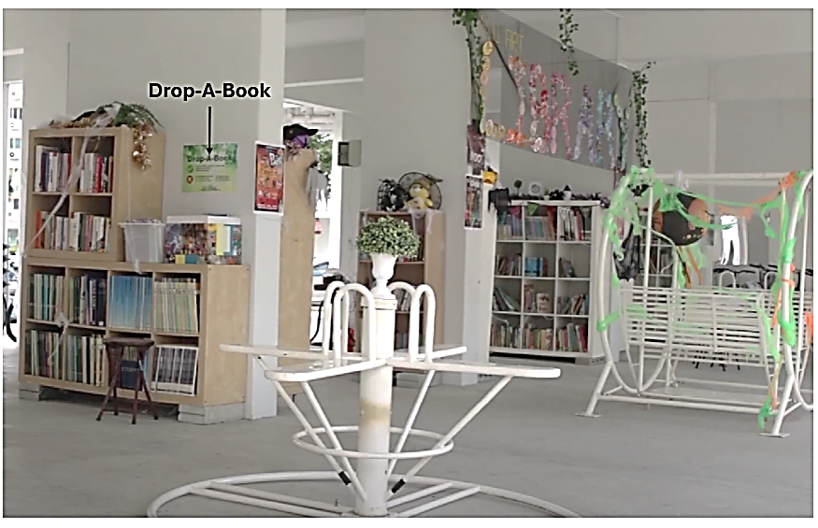
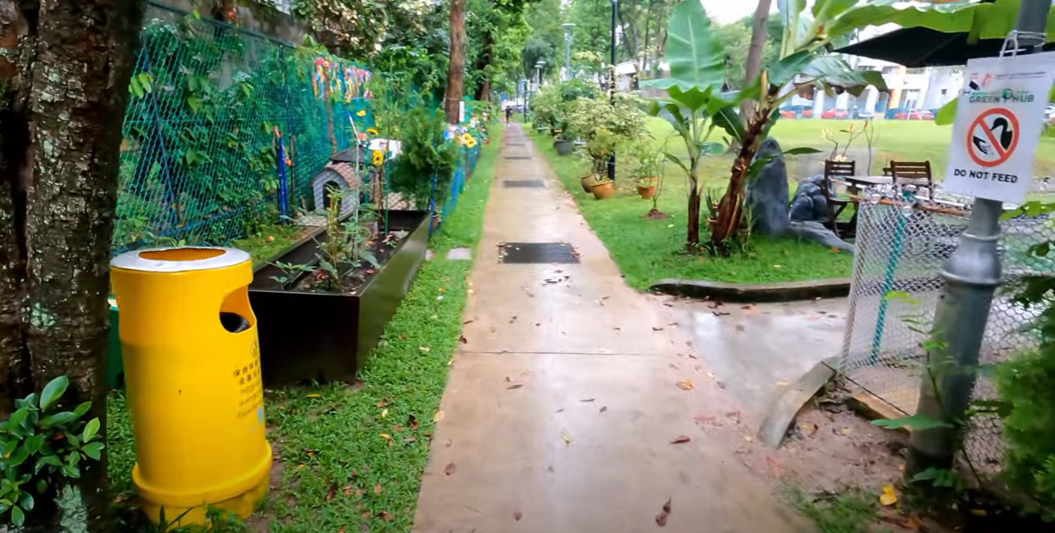

3

Resource 2 for Question 1

Summary of various eco-friendly features at Green Hub

Eco-Friendly Feature | Description
Smart recycling boxes (for general waste) | Residents may deposit their old clothes; used plastics; metal cans; newspaper and glass into the respective recycling boxes.
E-Waste recycling bins | Residents may deposit their old electronic accessories and devices into the recycling bin.
Food waste recycling | Residents may deposit leftover food into the waste recycling bin, transforms the food waste into animal feed or fertilisers for the community farm and garden.
Community library | Located in the void deck. Unwanted books donated by residents are displayed there for the community’s usage.
Community garden and farm | Community gardeners harvest green edibles and there are also farm animals such as ducks and chickens.

[Turn over
4

Resource 3 for Question 1

Survey questionnaire

- Are you aware of the Green Hub at Bishan?
  - Yes
  - No

- How often do you use the recycling features in Green Hub?
- None at all
- Once every few months
- Once a month
- At least once a week

- How often do you participate in Green Hub’s community gardening?
- None at all
- Once every few months
- Once a month
- At least once a week

- How often do you donate books to Green Hub’s community library?
- None at all
- Once every few months
- Once a month
- At least once a week

- Rate the following statements:

 | Neutral | Strongly Disagree | Disagree | Agree | Strongly Agree
The Green Hub has effectively increased my awareness of sustainability practices.

Since the introduction of the Green Hub, I have adopted more sustainable practices in my daily life.
I have noticed a positive change in the neighborhood’s overall sustainability efforts since the introduction of the Green Hub.

5

Resource 4 for Question 1

Survey results for Questions 2, 3 and 4 of the survey questionnaire

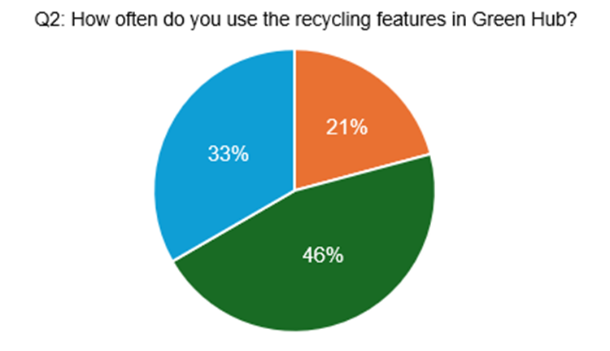
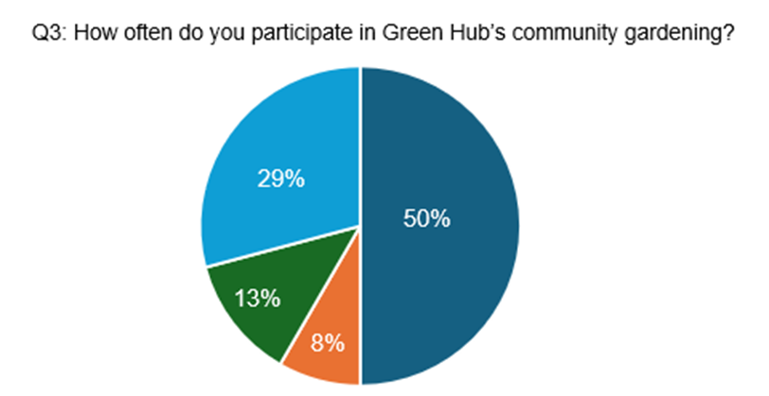
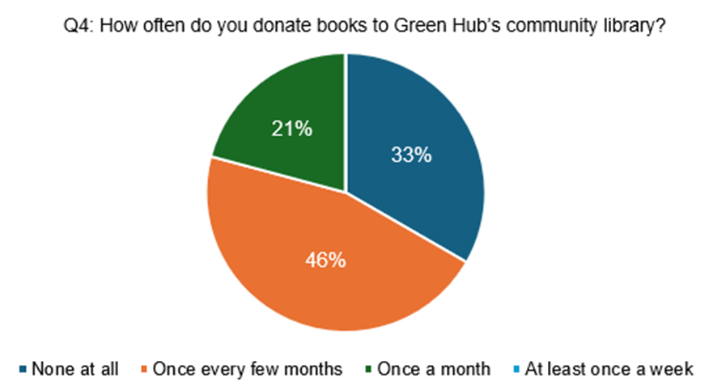

[Turn over
6

Resource 5 for Question 2

Relationship between temperature anomalies, atmospheric CO₂ and the number of sunspots from 1850 to 2000

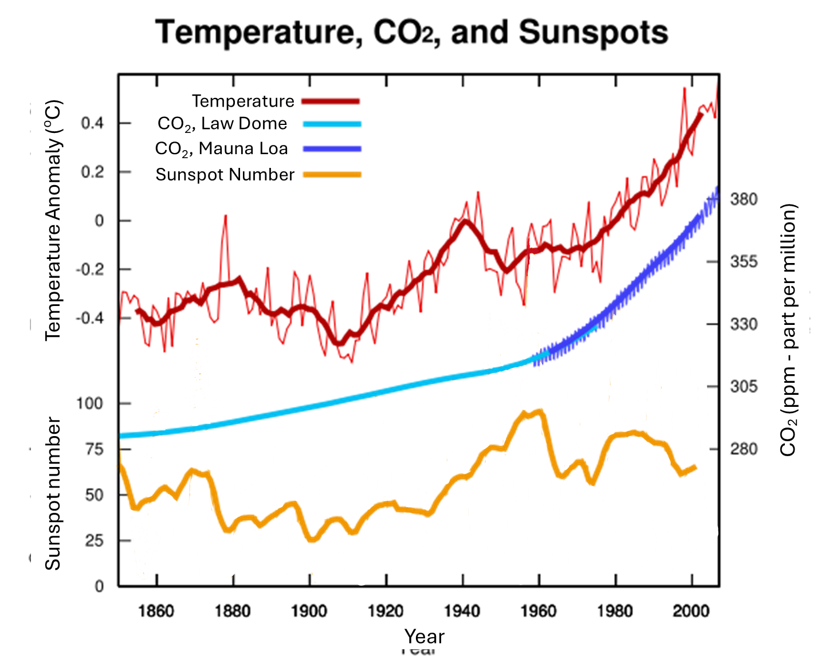

7
Resource 6A for Question 2
Changes in low-level cloud cover from 1850 to 2005
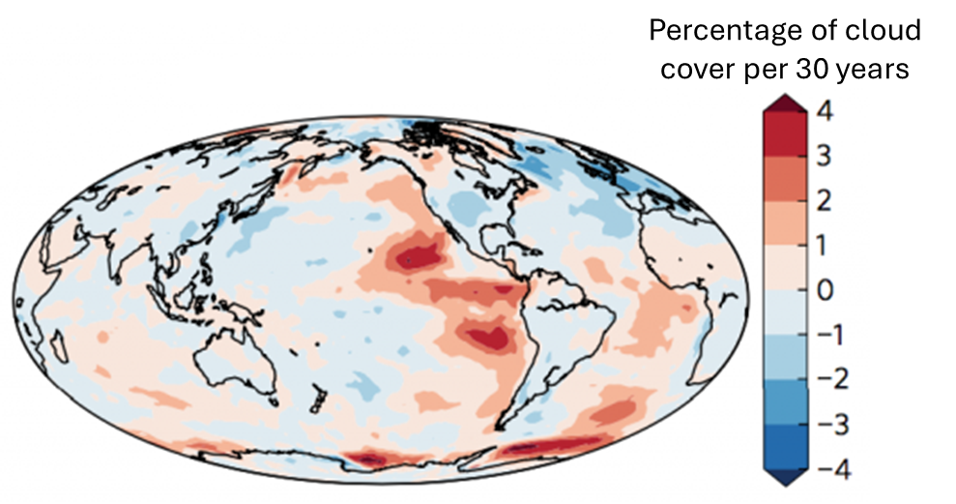

Resource 6B for Question 2

Changes in average surface temperature from 1980 to 2005
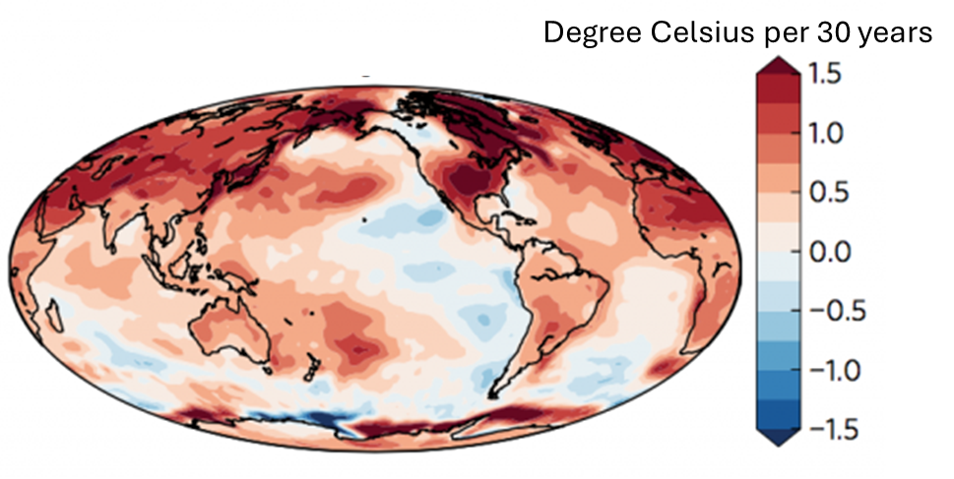

[Turn over
8
Resources 7A and 7B for Question 3

Geographical distribution of slum population across India districts (Resource 6A) and Mumbai wards (Resource 6B)

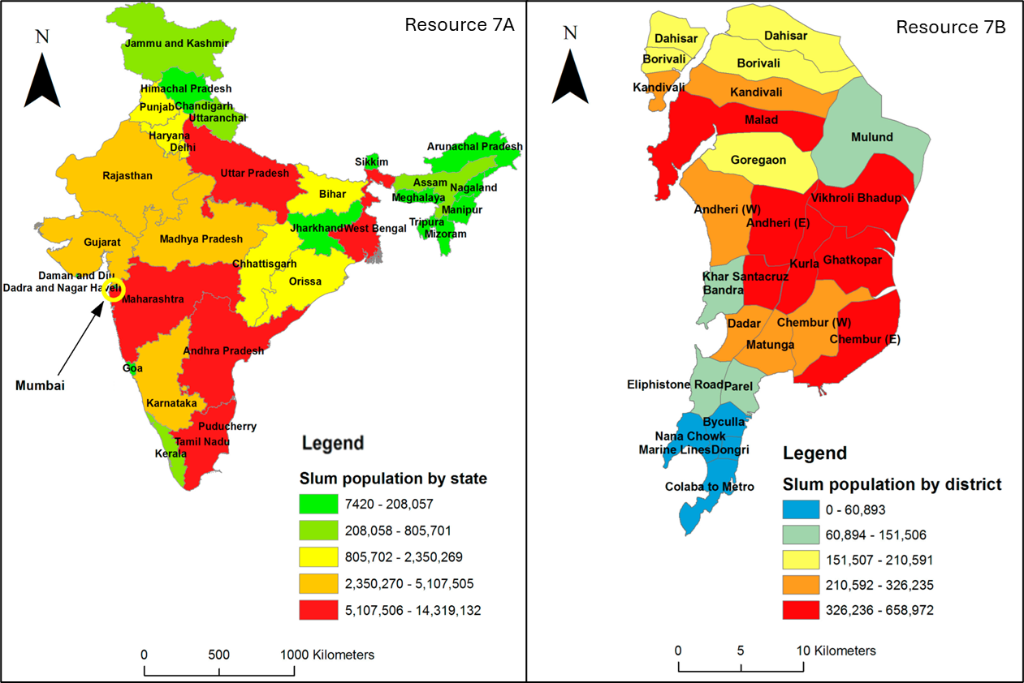

9

Resource 8 for Question 3

Location of Dharavi Slum in Mumbai, India

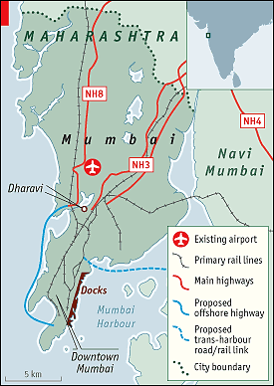

[Turn over
10

Resource 9 for Question 3

Factsheet on some locations in Dharavi slum in Mumbai, India

Locations | Function
13th Compound | Settlement where Mumbai’s plastic waste is recycled; Estimated to be the largest plastic recycling facility in India.
Kumbharwada | Potter settlement where homes double up as workplaces; Estimates of more than 800 homes involved in pottery
Koliwada | Fishing hamlet and one of the earliest settlers in Dharavi, Mumbai; Provides fishes to residents in Mumbai

Resource 10 for Question 3

Extract from news article on how climate change has brought about challenges for women living in urban slums

…Rising heat and heavier rains across South Asia, as the planet warms, are forcing home-based women workers to cut down on hours as their houses get hotter or are flooded often, resulting in a loss of income they cannot afford…

…Mamtaben, an Indian street-food vendor, has also seen her income shrink as heat and unseasonal rains reduce the length of time she can hawk her wares.

"Because the weather is so hot, all the food prepared gets spoilt and wasted if we don't sell it the same day," said Mamtaben. "In addition, nowadays, there is rainfall at any time of the year and any time of the day. When it rains, people don't come out to have street food ... when we don't meet our expected sales, we have to bear the loss"…

…In addition, the growing hours of unpaid care-work have [also] led to a dip in paid work for women, with increasing cases of heat-stroke and water-borne diseases affecting families...

…Amid a lack of awareness and measures to help them deal with climate change impacts, most of these "invisible" women workers are using negative coping strategies, including moving home or giving up their livelihoods... Researchers have therefore recommended the use of heat-resistant building materials and energy-efficient household appliances, and improving access to drinking water, as well as offering social security and financial assistance to upgrade homes as a strategies for women to consider…

11

BLANK PAGE

12

BLANK PAGE

